**User Guide**

install node version 10.16.0 ([**Link**](https://github.com/hammadshahid-170/node))

**Open CMD as administrator and below Commands:**

npm install -g gulp@3.9.1

npm install -g yo@3.1.0

npm install -g @microsoft/generator-sharepoint@1.12.1

npm install -g gulp-cli

After download code ([**Click Here**](https://github.com/pnp/sp-dev-fx-extensions/tree/main/samples/react-application-announcements)) open CMD as administrator and give location your code then run below Commands.

* npm i
* gulp clean
* gulp build --ship
* gulp bundle --ship
* gulp package-solution --ship

Then upload your package file on your Tenant.

Add package file in site Content of your Site.

**How to add the app to the site.**

**Step-1** After build package>go to AppCatalog of SharePoint>select Apps for SharePoint

Then upload your package

**Step-2** go to the site content of the site where you want to use and add this package in site content.

**I would also like instructions on how to re-deploy changes to the code after fixing the hardcoded URL problem.**

**Solution:**

After change Url you will run commands following below:

* gulp clean
* gulp build --ship
* gulp bundle --ship
* gulp package-solution --ship

Now Create List With Name(“**Announcements**”) With Columns See below Image

* Locale
* Announcement
* Link
* Urgent
* StartDateTime
* EndDateTime

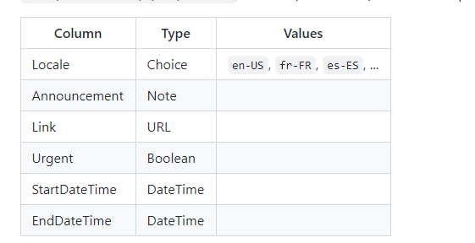

Now Open Window PowerShell As Administrator and Run following below commands:

**Step-1**  **Run Command:**

Install-Module SharePointPnPPowerShellOnline

After complete this command select ‘A’  see below image.

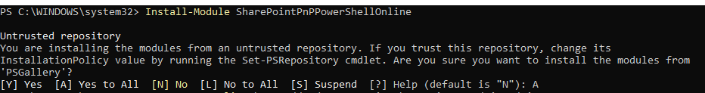

**Notice:** before run of powershell commands remove MultiFactor Authentication of your login user.

**Step-2**

Now Run  ‘Connect-PnPOnline [https://MyTenant.sharepoint.com/sites/MySite](https://mytenant.sharepoint.com/sites/MySite)’

Please Replace your Site url.

**Step-3**

Now give path you Project and Run this Command: See attached image below

Apply-PnPProvisioningTemplate sharepoint\assets\pnptemplate.xml -Handlers Fields,ContentTypes,Lists

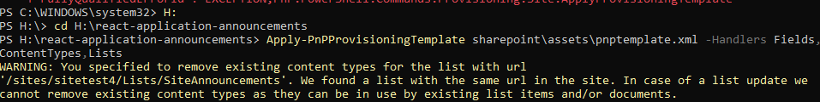

**Step-4**

**Now Run this Command:**

“ Add-PnPCustomAction -Name "Announcements" -Title "Announcements" -Location "ClientSideExtension.ApplicationCustomizer" -ClientSideComponentId "dd7ec4fd-97aa-44c5-b6ad-87535862e0bf" -ClientSideComponentProperties '{"listName":"Announcements", "siteUrl":"/sites/Contoso"}'  ”

Replace **Contoso** with your Site Name.

**Source link:** <https://github.com/pnp/sp-dev-fx-extensions/tree/main/samples/react-application-announcements>

Now Add Data in your list and Refresh your page.

